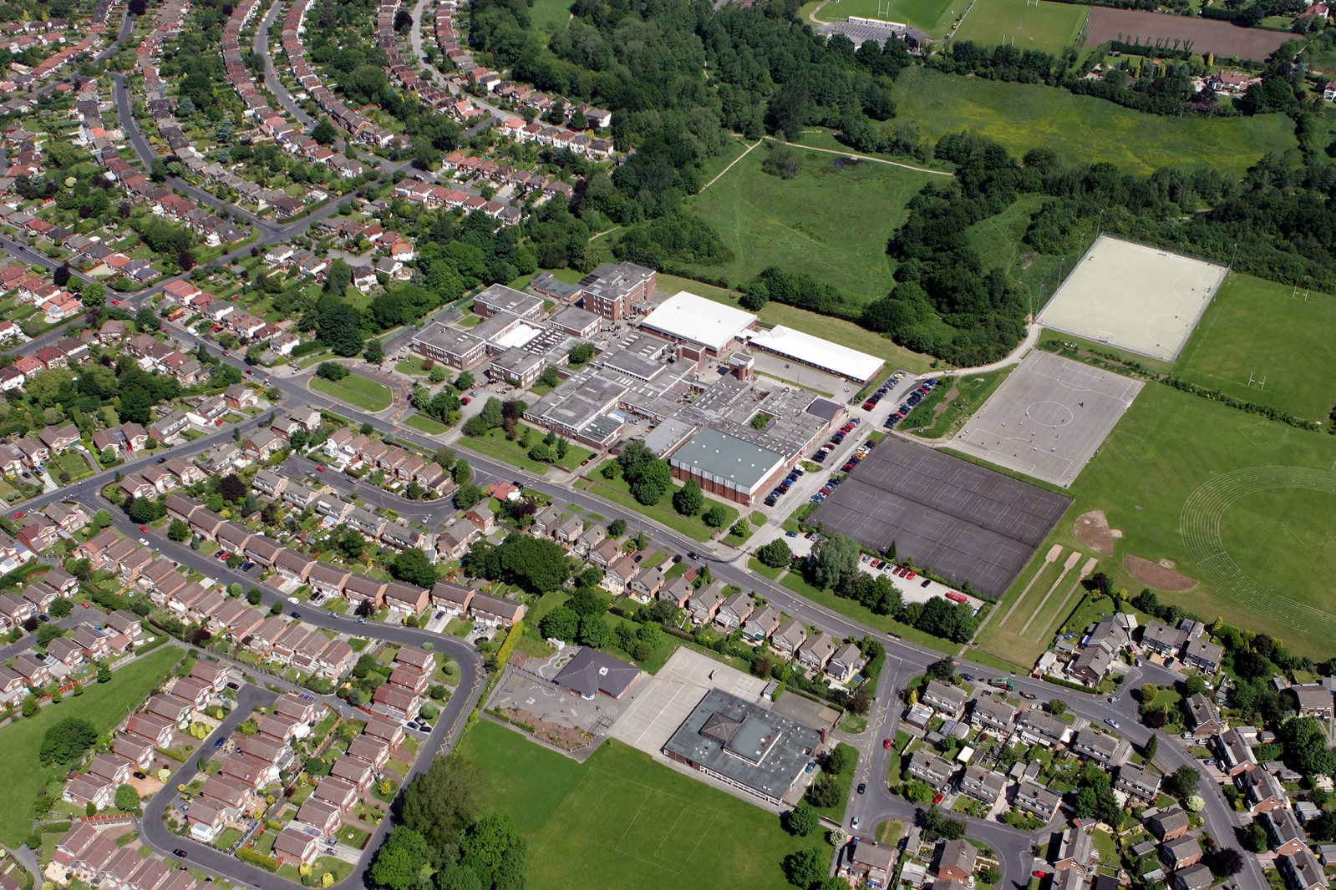

H

CURRICULUM POLICY

AUTHOR: N JOYNSON
REVIEW DATE: DECEMBER 2025
APPROVED DATE: DECEMBER 2025
NEXT REVIEW DATE: DECEMBER 2026

Intent

1. Curriculum Intent

At Bramhall High School, we continually strive to improve our curriculum diet for all students. Our focus is to foster the love of learning, ensuring each student is equipped with the knowledge and skills to be successful in future life. Each student embarks on a learning journey, which helps to prepare him or her for the future. This starts with a Year 7 curriculum designed to build upon the experiences in Key Stage 2 through to Year 11 and beyond. We want our students to leave with knowledge and skills which will not only create excellent life opportunities but will also prepare them exceptionally for life beyond school embracing the school’s vison of Every Student, Every subject, Every Grade.’ All subjects follow the relevant national curriculum programme of study. For more information please visit www.gov.uk/government/collections/national-curriculum
At Bramhall High School, students will:
- Experience a broad, deep and knowledge rich curriculum
- Have high expectations for behaviour and achievement
- Build their character
- Develop their cultural, social, moral, mental and physical development.

Students experience a broad, deep and knowledge rich curriculum

Our curriculum helps students to achieve high standards and make excellent progress. At KS3, the curriculum is broad and students learn essential knowledge built around a 'learning journey' to ensure they have a deep understanding across a range of subjects. There are many opportunities built into lessons to secure the need to recall and retrieve previous learning so that knowledge is fully embedded.

Many students have a clear idea of subjects they like the most and the least by the middle of Year 9 and offering choice at this stage engages students as partners in their learning and leads to improved outcomes.

In Years 10 and 11, the courses are carefully planned to ensure that content is thoroughly understood and this undoubtedly prepares students for external examinations at the end of the course. Secure foundations for progression.

Our Curriculum:
- Provide a broad and balanced education for all pupils that’s coherently planned and sequenced towards cumulatively sufficient knowledge for skills and future learning and employment.
- Ensure that the sequence of learning builds on previous knowledge whilst supporting future progression.
- Lead to qualifications that are of worth for employers and for entry to further and higher education.
- Enable all students to fulfil their potential.
- Meet the needs of students of all abilities at the school.
- Allow students to acquire an appreciation and respect for their own and other cultures.
- Prepare students to compete in the global economy.
- Prepare students to make informed choices at each point of their schooling.
- Help students develop lively, enquiring minds and the ability to question and argue rationally.
- Enable students to develop knowledge, understand concepts and acquire skills, and be able to choose and apply these in relevant situations
- Support students’ spiritual, moral, social and cultural development.
- Support students’ physical development and responsibility for their own health, and enable them to be active.
- Promote a positive attitude towards learning.
- Ensure equal access to learning for all pupils, with high expectations for every pupil and appropriate levels of challenge and support.
- Have a high academic/vocational/technical ambition for all pupils.
- Equip students with the knowledge and cultural capital they need to succeed in life.

Students will have high expectations for their behaviour and achievement

The school is inclusive and ambitious for all. We have high expectations of all students and provide opportunities for students to learn what is expected of them morally. Our Behaviour for Learning policy ensures that students learn that actions have consequences and they can accept and appreciate differences between people. Whilst students gain taught knowledge, we also want them to become learners who are enquiring, enthusiastic, engaged, and mannerly. Students will develop high expectations of themselves.

Students will build their character

At the school, we are totally committed to improving the life chances and aspirations of students. We ensure students have access to a wider curriculum, which provides numerous opportunities in sports, creativity, performing, and world of work, volunteering and membership. An extensive enrichment programme supports the development of students into well-rounded citizens:

- Music in its entirety
- 55 Sports Teams
- Drama Clubs and Theatre Productions
- The D of E Programme
- A range of clubs including Science, Chess and Creative Writing
- Overseas Visits: Battlefields; Berlin; Barcelona; Paris; Madrid and Ski Trips.
- School Trips: Lake District, Oxford University, Post 16 providers, STEM Trips, Manchester City.
- Community Links
- Student Leadership opportunities.

Students will develop their cultural, moral, social, mental and physical development

At Bramhall High School, we pride ourselves on delivering a curriculum for Personal Development (PD). This is championed at the school to develop students, not just academically, but to ensure that they are fully prepared for life in modern Britain. Our students can envision 'The Bigger Picture' and show that learning is linked to the real world and experiences. They are encouraged to take part in a range of sporting, cultural and charitable activities. Our links with local and national business enrich the curriculum offer and help to contextualise learning.

Students will secure foundations for progression
It is our intention at the school to ensure students have secure foundations for progression into further education and apprenticeships. From Year 8, students receive careers information with a clear focus on the Gatsby benchmarks and this is supported through drop-down days and a focused careers event. Over the course of 5 years, students receive a rigorous and bespoke aspirations programme that exposes our students to a huge range of experiences. All students receive one to one career guidance. Year 10 students undertake Work Experience. The Greater Manchester Challenge ethos supports our Careers provision.

Implementation

2. Legislation and Guidance

This policy reflects the requirements of the National Curriculum programmes of study, which all maintained schools in England must teach.
It also reflects requirements for inclusion and equality as set out in the Special Educational Needs and Disability Code of Practice 2014 and Equality Act 2010, and refers to curriculum-related expectations of governing boards set out in the Department for Education’s Governance Handbook.

Staff will ensure that the school curriculum is implemented in accordance with this policy.
Heads of Departments organise and sequence the knowledge for the best outcomes and fluidity of learning. They are held to account by their SLT Link.

3. Organisation and planning

Curriculum Implementation
The Bramhall High School believes that a carefully planned and structured curriculum is the foundation upon which excellent learning and development is built. The curriculum is designed and implemented in such a way that it builds on prior knowledge and prepares students for the next stage in their education.
Development of language and building knowledge are integral to curriculum planning. Subject Leaders, who are experts in their subjects, carefully construct a curriculum that promotes a deep understanding of a wide range of topics. Teachers plan learning that allows students to embed and recall knowledge through techniques such as interleaving of topics and spaced practice. This builds firm foundations for progression to the next level and exam success.

Years 7, 8 and 9

At Year 7, 8 and 9 the curriculum is designed around a learning journey. It encourages students to focus on deeper learning to ensure real understanding of key concepts. Students study 13 different subjects ensuring a broad and balanced diet. All students study a Modern Foreign Language, one of Spanish, German and French. We use a range of setting techniques to elicit the very best from our students and tailor our teaching to meet the needs of their learning. Our curriculum reflects academic rigour, whilst pastoral support is provided through our daily Form Tutor programme. Skills, knowledge and talents are built upon with students acquiring a very clear understanding of their strengths and weaknesses alongside how these influence their progress.
All students in years 7 to 9 will student the separate sciences of Biology, Chemistry and Physics.

Each Scheme of Learning has a planned learning journey with clear statements setting out what students need to know, understand and do to reach their aspirational target grade. The National Curriculum content is carefully tracked to ensure that students have covered all areas of subjects by the end of Year 9.

Year 7 Transition Pathway
This pathway enables students to transition into our school who need support with literacy and numeracy. This is led by a Primary Teacher and her team, focusing on nurture. Students receive specialist teaching in other areas with their peers. All students on the Transition Pathway study the full complement of subjects. This supports the transfer into classes.

Year 10 and 11

Options are structured in such a way to allow students a free choice. This ensures equity of delivery, with all students having equal access to subjects. The options are designed to stretch and challenge students and to meet the demands of the local labour market. Students are offered a mixture of practical and academic subjects from all areas of the curriculum. Within the option subjects, the school offers a range of different accreditation routes including academic and vocational options. This gives every pupil a broad and balanced curriculum, but still offers a flexibility to maximise the outcomes achieved by each individual. This model also maintains the widest possible choice for progression routes Post 16 as every pupil will have a greater range of subjects on which to choose future opportunities for education and training. An additional suite of Vocational Qualifications has been developed.

Learning Journeys and Long-Term plans are available on the school website.

All Learning Journeys and Long-Term Plans are carefully sequenced, so that knowledge is built upon and revisited in re-call. Departments revisit the sequence of learning on a regular basis to review.

The Recovery Programme due to past disruptions to learning.

“Teach an ambitious and broad curriculum in all subjects from the start of the Academic Year. To make use of existing flexibilities to create time to cover the most important missed content or knowledge that is less secure.”

It is vital that we continue to embrace all subjects. That we utilise our expertise and interventions do not become a circus. That we support students in their pastoral development and create the resilience for learning.
Heads of Departments have worked with their departments tirelessly to ensure that they have a clear plan to ensure that any missed learning is caught up. Learning journeys have been reassessed and work covered during the period of lockdown analysed. This is an ongoing process.

4. Inclusion

Teachers set high expectations for all pupils. They will use appropriate assessment to set ambitious targets and plan challenging work for all groups, including:
- More able pupils
- Pupils with low prior attainment
- Pupils from disadvantaged backgrounds
- Pupils with SEN
- Pupils with English as an additional language (EAL)
Teachers will plan lessons so that pupils with SEN and/or disabilities can study every National Curriculum subject, wherever possible, and ensure that there are no barriers to every pupil achieving.
Teachers will also take account of the needs of pupils whose first language is not English. Lessons will be planned so that teaching opportunities help pupils to develop their English, and to support pupils to take part in all subjects.
Further information can be found in our statement of equality information and objectives, and in our SEN policy and information report. Please see Appendix 1 regarding the dropping of subjects.

5. Links with other policies

This policy links to the following policies and procedures:
- Assessment guidelines;
- SEND policy;
- Equality information and objectives;
- Teaching and Learning Guidelines.

Impact

6. Roles and responsibilities
6.1 The Governing Body
The Governing Body will monitor the effectiveness of this policy and hold the headteacher to account for its implementation.
The governing board will also ensure that:
- A robust framework is in place for setting curriculum priorities and aspirational targets
- Enough teaching time is provided for pupils to cover the National Curriculum and other statutory requirements
- All courses provided for pupils below the age of 17 that lead to qualifications, such as GCSEs are approved by the secretary of state
- The school implements the relevant statutory assessment arrangements
- It participates actively in decision-making about the breadth and balance of the curriculum
- Pupils are provided with independent, impartial careers guidance, and that this is appropriately resourced
6.2 Headteacher
The headteacher is responsible for ensuring that this policy is adhered to, and that:
- All required elements of the curriculum, and those subjects which the school chooses to offer, have aims and objectives which reflect the aims of the school and indicate how the needs of individual pupils will be met
- The amount of time provided for teaching the required elements of the curriculum is adequate and is reviewed by the governing board
- Where appropriate, the individual needs of some pupils are met by permanent or temporary disapplication from all or part of the National Curriculum
- They manage requests to withdraw children from curriculum subjects, where appropriate
- The school’s procedures for assessment meet all legal requirements
- The governing body is fully involved in decision-making processes that relate to the breadth and balance of the curriculum
- The governing body is advised on whole-school targets in order to make informed decisions
- Proper provision is in place for pupils with different abilities and needs, including children with SEN

7. Monitoring arrangements

Governors monitor coverage of National Curriculum subjects and compliance with other statutory requirements through:
- Rigorous questioning in Governors’ Meetings
- Presentations to Governors
- Governor link meetings with departments
- Senior School SIP Audits
Heads of Departments monitor the way their subject is taught throughout the school by:
1.Planning scrutiny;
2. Learning walks;
3. Book scrutiny;
4. Student Voice.

Heads of Department also have responsibility for monitoring the way in which resources are stored and managed.
This policy will be reviewed every 12 months by [the headteacher, Mr Williams, Ms Joynson SDHT At every review, the policy will be shared with the full Governing Body

Appendix 1
Dropping or changing subjects.

Please note that while the below references KS4 the principles can broadly be applied to KS3 with the exception of the requirement for HODs to report back.

Unless there are exceptional circumstances (which are listed below) the option of ‘dropping subjects’ does not exist. Once a student has opted for a subject in KS4 they are committed to that subject for the duration of the key stage and must be entered for appropriate accredited certification at the end of the key stage. In most cases certification is for GCSE or a vocational qualification, as decided by the Head of Department (HOD). The grading of these subjects (9 to 1 for GCSE and L2Distinction * to L1 Pass for vocational qualifications) are designed to cover students of all abilities.

It is the responsibility of the teacher, under the direction and support of the HOD, to ensure that the students are engaged in that subject for the whole of the key stage, and that they support the student to achieve their target grade (or higher) in that subject at the end of the key stage. ‘Not coping’ or ‘not enjoying’ the subject does not justify the student dropping the subject. If a student is not coping, or not enjoying a subject, the teacher has a responsibility to deal with this, supported, if necessary, by the HOD. This includes lack of progress resulting from poor attendance. In the case of poor attendance, the teacher should alert the HOD/Head of Year (HOY)/Form Tutor that they have a concern at an early stage before the problem escalates.

There are many strategies to deal with students that aren’t engaged and/or coping in a subject. Teachers must start by looking at their own teaching and strategies they use in the classroom. Ultimately, if normal classroom strategies and targeted intervention/support by the teacher don’t work, then the normal referral process should be used i.e. referral by the teacher to the HOD for higher level support, including contacting parents, additional time or sessions for catching up missed work. If the problem persists, then the HOD should seek the support of the relevant member of their senior leadership (SLT) link, especially if the problem is caused by poor attendance.

Exceptions
There are two exceptions, which in exceptional circumstances could permit a student to drop a subject. In these situations the student is re-timetabled to a support group:

- If a student has got significant learning difficulties and is on the SEN register (i.e has an EHCP): In this case the Subject Leader/SENDCO/HOY should refer the issue to the senior leadership link, who will assess whether dropping the subject and re-timetabling for support learning is an option. This assessment should be done in consultation with the Senior Deputy Head (Curriculum and timetabling). The student will then be raised the student at the next available SLT meeting. The Headteacher* will make the final decision given the all the information presented by the SLT link.

- If a student has significant emotional or health problems, which are affecting the student’s ability to achieve in the subject: In this case the Subject Leader/SENDCO/HOY should refer the issue to the SLT link, who will assess whether dropping the subject and re-timetabling for support learning is an option. This assessment should be done in consultation with the Senior Deputy Head (Curriculum and timetabling). It may be that the student requires a referral for an alternative provision, in which case the SLT responsible for AP should be involved. Once the assessment is completed, the student will be raised at the next available SLT meeting. The Headteacher* will make the final decision.

*If the Headteacher is also the SLT link to the department the decision will defer to the Senior Deputy Headteacher.

Students are not allowed to change subjects in the option blocks after October 10th of Year 10. Even within this period of time a request to change a subject will be treated as an exceptional and unusual request and treated as such because any change of subject will require the student to work hard to catch up on work that they have missed in their new subject. Such requests will be managed by the Senior Deputy Headteacher, working with other senior leaders and pastoral staff. Approval will only be given if the student has a proven record of good work ethic, which will enable him or her to catch up on work missed, and after the situation has been discussed with parents.

From September 2026 the number of students not completing each KS4 subject will be reflected in the school’s internal exam analysis.

Checklist or Flow Chart
In this case the Subject Leader/HOY should refer the issue to the SLT link and/or SENCO, if appropriate, who will assess whether dropping the subject is an option and if they can be housed in an alternative location. This should be done in consultation with the Senior Deputy (Curriculum & timetabling). Once the assessment is completed, the SLT link will present this at the next available SLT meeting.
If a student has got significant learning difficulties and is on the SEN register (i.e. has an EHCP)

There are two exceptions, which in exceptional circumstances could permit a student to drop a subject. In these situations, the student is re-timetabled to a support group:

If a student is not coping, or not enjoying a subject, the teacher has a responsibility to deal with this, supported, if necessary, by the HOD. This includes lack of progress resulting from poor attendance. In the case of poor attendance, the teacher should alert the HOD/Head of Year (HOY)/Form Tutor that they have a concern at an early stage before the problem escalates.
Once a student has opted for a subject in KS4 they are committed to that subject for the duration of the key stage and must be entered for appropriate accredited certification at the end of the key stage.

The Headteacher* will make the final decision. If the Headteacher is the also the Line Manager the decision will revert to the Senior Deputy.
If a student has significant emotional or health problems, which are affecting the student’s ability to achieve in the subject:

