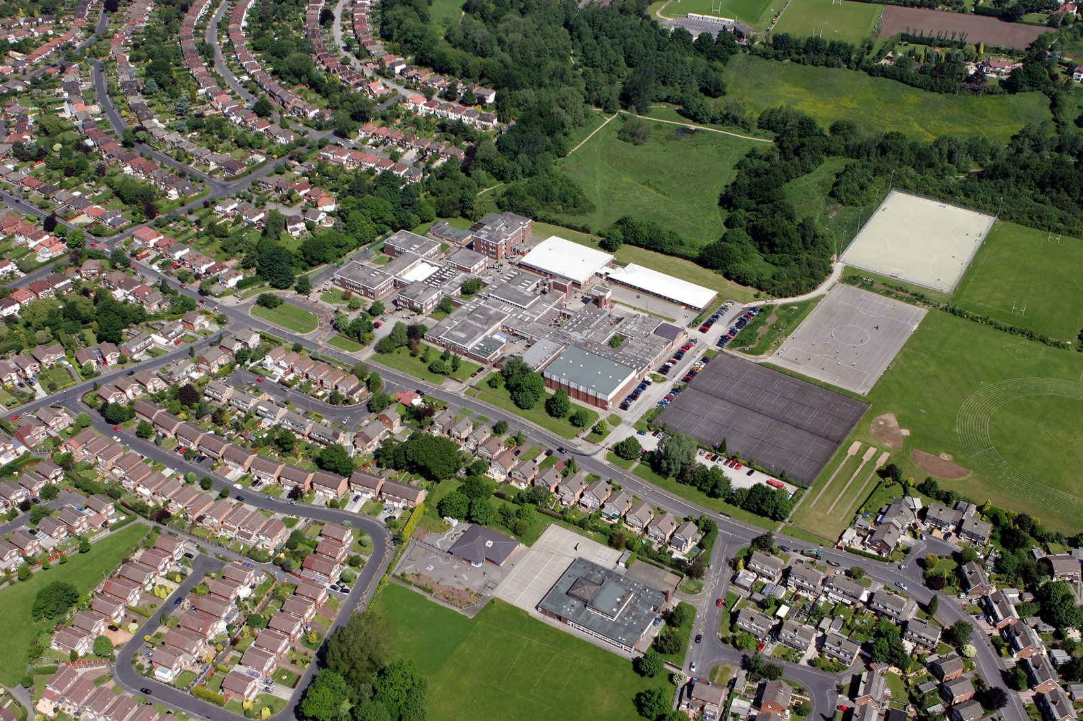



fgf
DOCUMENT TITLE
SUBTITLE

AUTHOR:
REVIEW DATE:
DEPARTMENT | ENGLISH

Departments to complete the ‘careers activities in departments’ column. Please note we do not expect departments to cover all benchmarks.

Benchmark | Examples of activities | Careers activities in departments
Benchmark 2 Learning from career and labour market information  All pupils, parents and carers, teachers and staff who support pupils have access to good-quality, up-to-date information about future pathways, study options and labour market opportunities. | - Information about future pathways  - Information about the labour market for parents.  - Information about the labour market for pupils/carers.  - STEM | Description of Activities:  Year 7:  Smart- Forensics, police work, news reporting, disability awareness, charity work, being an artist.  Introduction to Shakespeare- being a writer, actor, historian, oracy skills.  Year 8:  Noughts and Crosses- Politics, public speaking, campaigns.  Dystopian Literature and the Environment- radio presenting, environmental campaigning, charity work.  Much Ado About Nothing- being a writer, actor, historian, oracy skills.  Year 9:  The Woman in Black- careers in law, events planning.  Othello- being a writer, actor, historian, oracy skills.  Festivals and Travel Writing- journalism, blog writing, online presence.  Year 10:  Power (An Inspector Calls and poetry)- politics.  The Natural World- Language Paper 2, Q5 (point of view writing).  Conflict- Macbeth and poetry (being a writer, actor, historian, oracy skills).
Benchmark 3: Addressing the needs of each young person  Students have different career guidance needs at different stages. Opportunities for advice and support need to be tailored to the needs of each student. | - Aspiration raising  - Addressing stereotypes  - SEND and vulnerable students  - Local authority collaboration  - Other | Description of Activities:  Year 7:  Smart- Autism awareness, bullying, homelessness  Year 8:  Much Ado About Women- aspirations for women, exploring relationships, gender stereotypes.  Year 9:  Othello- exploring relationships, gender stereotypes.  Unseen texts- addressing stereotypes (soldiers as vulnerable).  Year 10: Power- position of women in society, class system, Capitalism, Socialism, gender roles.  Year 11  Corruption and Poverty (A Christmas Carol)- addressing stereotypes, the importance of social welfare.
Benchmark 4: Linking curriculum learning to careers  All teachers should link curriculum learning with careers. Subject teachers should highlight the progression routes for their subject and the relevance of the knowledge and skills developed in their subject for a wide range of career pathways. | - Careers embedded in the curriculum  - Employer involvement  - Employer mentoring  - Events & talks  - Business games & competitions  - Alumni activities  - Ready for work activities  - Employer encounters with parents  - Youth social action (campaigning, fundraising, volunteering)  - Other | Description of Activities:  Ready for Work Activities- Each year group does a spoken language presentation which is good preparation for individual verbal confidence and workplace articulation.
Benchmark 5:  Employer encounters  Every student should have multiple opportunities to learn from employers about work, employment and the skills that are valued in the workplace. This can be through a range of enrichment activities including visiting speakers, mentoring and enterprise schemes | - Employer involvement in the curriculum  - Employer mentoring  - Events talks involving employers  - Business games and competitions  - Alumni activities  - Ready for work activities with employers  - Continuing professional development  - Workplace experience with parents  - Youth action (campaigning, fundraising, volunteering)  - other | Description of Activities:  Visiting authors in the library.  Youth Action- Environmental campaigning (year 8).
Benchmark 6:  Workplace experience  Every student should have first-hand experiences of the workplace through work visits, work shadowing and/or work experience to help their exploration of career opportunities, and expand their networks. | - Volunteering  - Work experience  - Job shadowing  - Workplace visits  - Continuing professional development  - Workplace experience with parents  - Youth social action (campaigning, fundraising, volunteering)  - Other | Description of Activities:  Work experience placements in media, publishing, or communications.  New York Visit included. Broadway Experience: Attended a live performance of The Great Gatsby on Broadway. Students critically reflected on the adaptation of Fitzgerald’s novel for the stage, exploring careers in scriptwriting, directing, acting, and literary criticism.  Cultural and Historical Literacy: Visited the 9/11 Memorial Museum and the Statue of Liberty to deepen understanding of American identity, resilience, and storytelling through public history. These visits supported discussions around careers in journalism, museum curation, and public speaking.  Digital Writing and Media: Students were given the opportunity to create personal blogs documenting their experiences, developing skills in travel writing, digital publishing, and content creation, key competencies for careers in media, communications, and freelance writing.
Benchmark 7:  Encounters with further and higher education.  All students should understand the full range of learning opportunities that are available to them. This includes both academic and vocational routes and learning in schools, colleges, universities and in the workplace. | - Further education events and visits  - Application support for further education  - Higher education events and visits  - Apprenticeship events and visits  - Application support for apprenticeships  - Educational encounters with parents  - Other | Description of Activities:  Assembly talks from local colleges and sixths forms about both academic and vocational routes.
Benchmark 8  Personal guidance | - One to one careers guidance  - Group careers guidance  - Other | Description of Activities:

