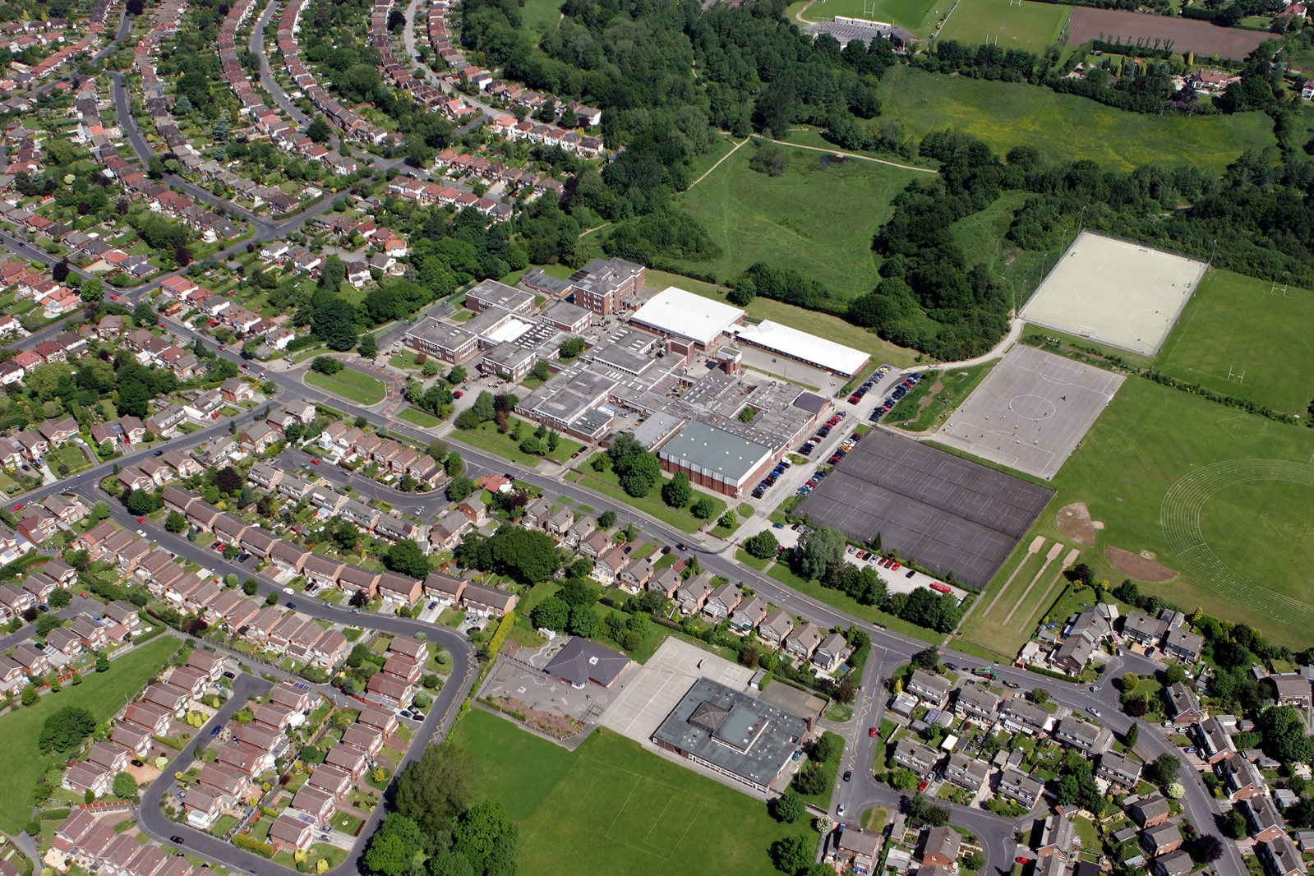



fgf
DOCUMENT TITLE
SUBTITLE

AUTHOR:
REVIEW DATE:
DEPARTMENT | MATHS

Departments to complete the careers activities in departments column. Please note we do not expect departments to cover all benchmarks. Some activities can be used for more than one benchmark.

Benchmark | Examples of activities | Careers activities in departments
Benchmark 2 Learning from career and labour market information  All pupils, parents and carers, teachers and staff who support pupils should have access to good-quality, up-to-date information about future pathways, study options and labour market opportunities. | - Information about future pathways  - Information about the labour market for parents.  - Information about the labour market for pupils/carers.  - STEM | Description of Activities:  Stockport Post 16 careers week – subject videos shown in lessons which highlight the local labour market information.  Year 9 Options talks – subject teachers explain where each subject can take them and what skills are needed for each subject.  Year 9 Options evening – Post 16 pathways and opportunities explained.  Maths teachers share labour market data showing demand for numeracy, data analysis, finance, engineering. Careers posters in classrooms highlighting jobs like actuary, data scientist, accountant.
Benchmark 3: Addressing the needs of each young person  Students have different career guidance needs at different stages. Opportunities for advice and support need to be tailored to the needs of each student. | - Aspiration raising  - Addressing stereotypes  - SEND and vulnerable students  - Record keeping  - Destination data  - Local authority collaboration  - Other | Description of Activities:  Small group support for SEND students linking maths skills to practical careers (e.g., retail, construction).
Benchmark 4: Linking curriculum learning to careers  All teachers should link curriculum learning with careers. Subject teachers should highlight the progression routes for their subject and the relevance of the knowledge and skills developed in their subject for a wide range of career pathways. | - Careers embedded in the curriculum  - Employer involvement  - Employer mentoring  - Events & talks  - Business games & competitions  - Alumni activities  - Ready for work activities  - Employer encounters with parents  - Youth social action (campaigning, fundraising, volunteering)  - Other | Description of Activities:  Teachers highlight career links when teaching topics (e.g., statistics - medical research, algebra - coding, geometry - architecture).  Maths national competition: UKMT Maths challenge.
Benchmark 5:  Employer encounters  Every student should have multiple opportunities to learn from employers about work, employment and the skills that are valued in the workplace. This can be through a range of enrichment activities including visiting speakers, mentoring and enterprise schemes | - Employer involvement in the curriculum  - Employer mentoring  - Events talks involving employers  - Business games and competitions  - Alumni activities  - Ready for work activities with employers  - Continuing professional development  - Workplace experience with parents  - Youth action (campaigning, fundraising, volunteering)  - other | Description of Activities:  Year 9 Careers morning: Guest speakers from banks, insurance firms, engineering companies explaining how maths underpins their work.
Benchmark 6:  Workplace experience  Every student should have first-hand experiences of the workplace through work visits, work shadowing and/or work experience to help their exploration of career opportunities, and expand their networks. | - Volunteering  - Work experience  - Job shadowing  - Workplace visits  - Continuing professional development  - Workplace experience with parents  - Youth social action (campaigning, fundraising, volunteering)  - Other | Description of Activities:  Work experience placements in finance, accountancy, engineering firms.
Benchmark 7:  Encounters with further and higher education.  All students should understand the full range of learning opportunities that are available to them. This includes both academic and vocational routes and learning in schools, colleges, universities and in the workplace. | - Further education events and visits  - Application support for further education  - Higher education events and visits  - Apprenticeship events and visits  - Application support for apprenticeships  - Educational encounters with parents  - Other | Description of Activities:  Assembly talks from local colleges and sixths forms about both academic and vocational routes.
Benchmark 8  Personal guidance | - One to one careers guidance  - Group careers guidance  - Other | Description of Activities:

