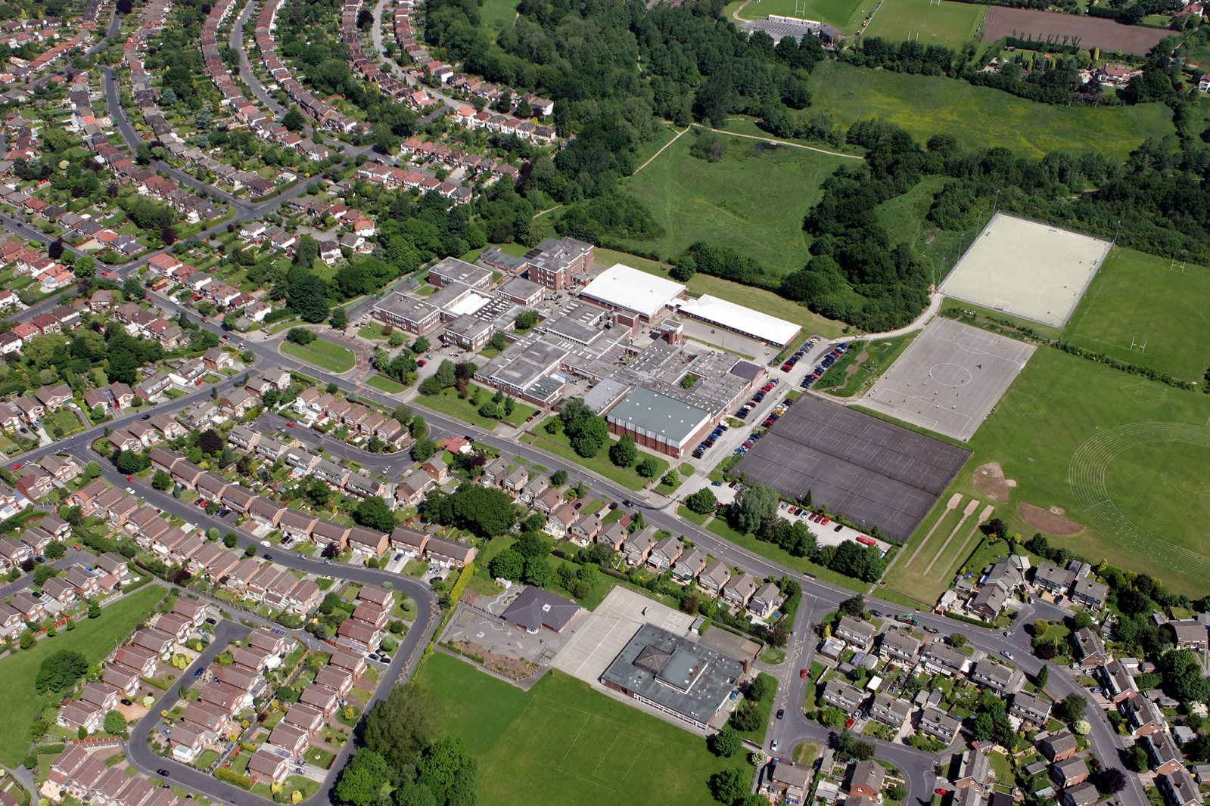



fgf
DOCUMENT TITLE
SUBTITLE

AUTHOR:
REVIEW DATE:
DEPARTMENT | Drama

Departments to complete the ‘careers activities in departments’ column. Please note we do not expect departments to cover all benchmarks.

Benchmark | Examples of activities | Careers activities in departments
Benchmark 2 Learning from career and labour market information  All pupils, parents and carers, teachers and staff who support pupils have access to good-quality, up-to-date information about future pathways, study options and labour market opportunities. | - Information about future pathways  - Information about the labour market for parents.  - Information about the labour market for pupils/carers.  - STEM | Description of Activities:  Year 9 Option Talks: subject teachers explain where Drama related qualifications can take them and what skills are needed for this  Year 9 Option evenings: Post 16 pathways and opportunities are explained  Year 9 Parents evening: Drama Post 16 pathways are explained to parents and students  Post 16 Option displays in classrooms: Long Term Plans and apprenticeships posters
Benchmark 3: Addressing the needs of each young person  Students have different career guidance needs at different stages. Opportunities for advice and support need to be tailored to the needs of each student. | - Aspiration raising  - Addressing stereotypes  - SEND and vulnerable students  - Local authority collaboration  - Other | Performers, Directors, Lighting, Sound, Costume and Set Designers: GCSE students analyse and evaluate the work of professional production teams and the effects they create on stage for the audience.
Benchmark 4: Linking curriculum learning to careers  All teachers should link curriculum learning with careers. Subject teachers should highlight the progression routes for their subject and the relevance of the knowledge and skills developed in their subject for a wide range of career pathways. | - Careers embedded in the curriculum  - Employer involvement  - Employer mentoring  - Events & talks  - Business games & competitions  - Alumni activities  - Ready for work activities  - Employer encounters with parents  - Youth social action (campaigning, fundraising, volunteering)  - Other | Description of Activities:  Ready for work activities;  KS3 and GCSE Theatre Trip  Leadership opportunities: Year 9 students experience working with Year 4/5/6 primary students from four primary schools as a part of ‘Year 9 Performance Project’.
Benchmark 5:  Employer encounters  Every student should have multiple opportunities to learn from employers about work, employment and the skills that are valued in the workplace. This can be through a range of enrichment activities including visiting speakers, mentoring and enterprise schemes | - Employer involvement in the curriculum  - Employer mentoring  - Events talks involving employers  - Business games and competitions  - Alumni activities  - Ready for work activities with employers  - Continuing professional development  - Workplace experience with parents  - Youth action (campaigning, fundraising, volunteering)  - other | Description of Activities:  Alumni activities: Ex-students present at our PE Celebration evening to explain their sporting journey to parents and students
Benchmark 6:  Workplace experience  Every student should have first-hand experiences of the workplace through work visits, work shadowing and/or work experience to help their exploration of career opportunities, and expand their networks. | - Volunteering  - Work experience  - Job shadowing  - Workplace visits  - Continuing professional development  - Workplace experience with parents  - Youth social action (campaigning, fundraising, volunteering)  - Other | Description of Activities:  KS3 and GCSE Theatre Trips
Benchmark 7:  Encounters with further and higher education.  All students should understand the full range of learning opportunities that are available to them. This includes both academic and vocational routes and learning in schools, colleges, universities and in the workplace. | - Further education events and visits  - Application support for further education  - Higher education events and visits  - Apprenticeship events and visits  - Application support for apprenticeships  - Educational encounters with parents  - Other | Description of Activities:
Benchmark 8  Personal guidance | - One to one careers guidance  - Group careers guidance  - Other | Description of Activities:  6th Form information: Staff from Aquinas College explain post 16 provision and career opportunities to the GCSE cohort

