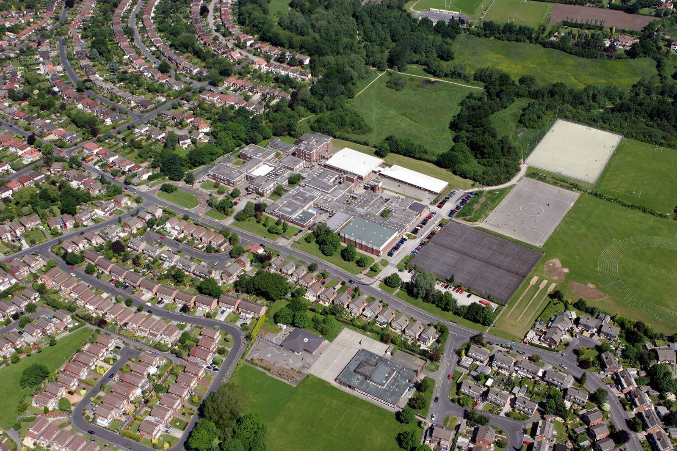



fgf
DOCUMENT TITLE
SUBTITLE

AUTHOR:
REVIEW DATE:
DEPARTMENT | ART

Departments to complete the ‘careers activities in departments’ column. Please note we do not expect departments to cover all benchmarks.

Benchmark | Examples of activities | Careers activities in departments
Benchmark 2 Learning from career and labour market information  All pupils, parents and carers, teachers and staff who support pupils have access to good-quality, up-to-date information about future pathways, study options and labour market opportunities. | - Information about future pathways  - Information about the labour market for parents.  - Information about the labour market for pupils/carers.  - STEM | Description of Activities:  Year 9 Option Talks: subject teachers explain where PE related qualifications can take them and what skills are needed for this  Year 9 Option evenings: Post 16 pathways and opportunities are explained  Year 9 Parents evening: PE Post 16 pathways are explained to parents and students
Benchmark 3: Addressing the needs of each young person  Students have different career guidance needs at different stages. Opportunities for advice and support need to be tailored to the needs of each student. | - Aspiration raising  - Addressing stereotypes  - SEND and vulnerable students  - Local authority collaboration  - Other | Description of Activities:  6th Form information: Staff from Aquinas College explain various post 16 provision and career opportunities to our GCSE students
Benchmark 4: Linking curriculum learning to careers  All teachers should link curriculum learning with careers. Subject teachers should highlight the progression routes for their subject and the relevance of the knowledge and skills developed in their subject for a wide range of career pathways. | - Careers embedded in the curriculum  - Employer involvement  - Employer mentoring  - Events & talks  - Business games & competitions  - Alumni activities  - Ready for work activities  - Employer encounters with parents  - Youth social action (campaigning, fundraising, volunteering)  - Other | Description of Activities:  Ready for work activities;  Skills Leadership Foundation qualifications: KS4 students complete a leadership qualification during their Core PE lessons  Officiating opportunities: Students with officiating qualifications are used to referee inter house matches  Leadership opportunities: Students experience working with primary school students during a variety of activities including helping at Sports Days and indoor athletics competitions
Benchmark 5:  Employer encounters  Every student should have multiple opportunities to learn from employers about work, employment and the skills that are valued in the workplace. This can be through a range of enrichment activities including visiting speakers, mentoring and enterprise schemes | - Employer involvement in the curriculum  - Employer mentoring  - Events talks involving employers  - Business games and competitions  - Alumni activities  - Ready for work activities with employers  - Continuing professional development  - Workplace experience with parents  - Youth action (campaigning, fundraising, volunteering)  - other | Description of Activities:  Alumni activities: Ex students present at our PE Celebration evening to explain their sporting journey to parents and students
Benchmark 6:  Workplace experience  Every student should have first-hand experiences of the workplace through work visits, work shadowing and/or work experience to help their exploration of career opportunities, and expand their networks. | - Volunteering  - Work experience  - Job shadowing  - Workplace visits  - Continuing professional development  - Workplace experience with parents  - Youth social action (campaigning, fundraising, volunteering)  - Other | Description of Activities:  Ex students are mentored in the department during their Yr12 work experience
Benchmark 7:  Encounters with further and higher education.  All students should understand the full range of learning opportunities that are available to them. This includes both academic and vocational routes and learning in schools, colleges, universities and in the workplace. | - Further education events and visits  - Application support for further education  - Higher education events and visits  - Apprenticeship events and visits  - Application support for apprenticeships  - Educational encounters with parents  - Other | Description of Activities:
Benchmark 8  Personal guidance | - One to one careers guidance  - Group careers guidance  - Other | Description of Activities:  6th Form information: Staff from Aquinas College explain various post 16 provision and career opportunities to our GCSE cohort

