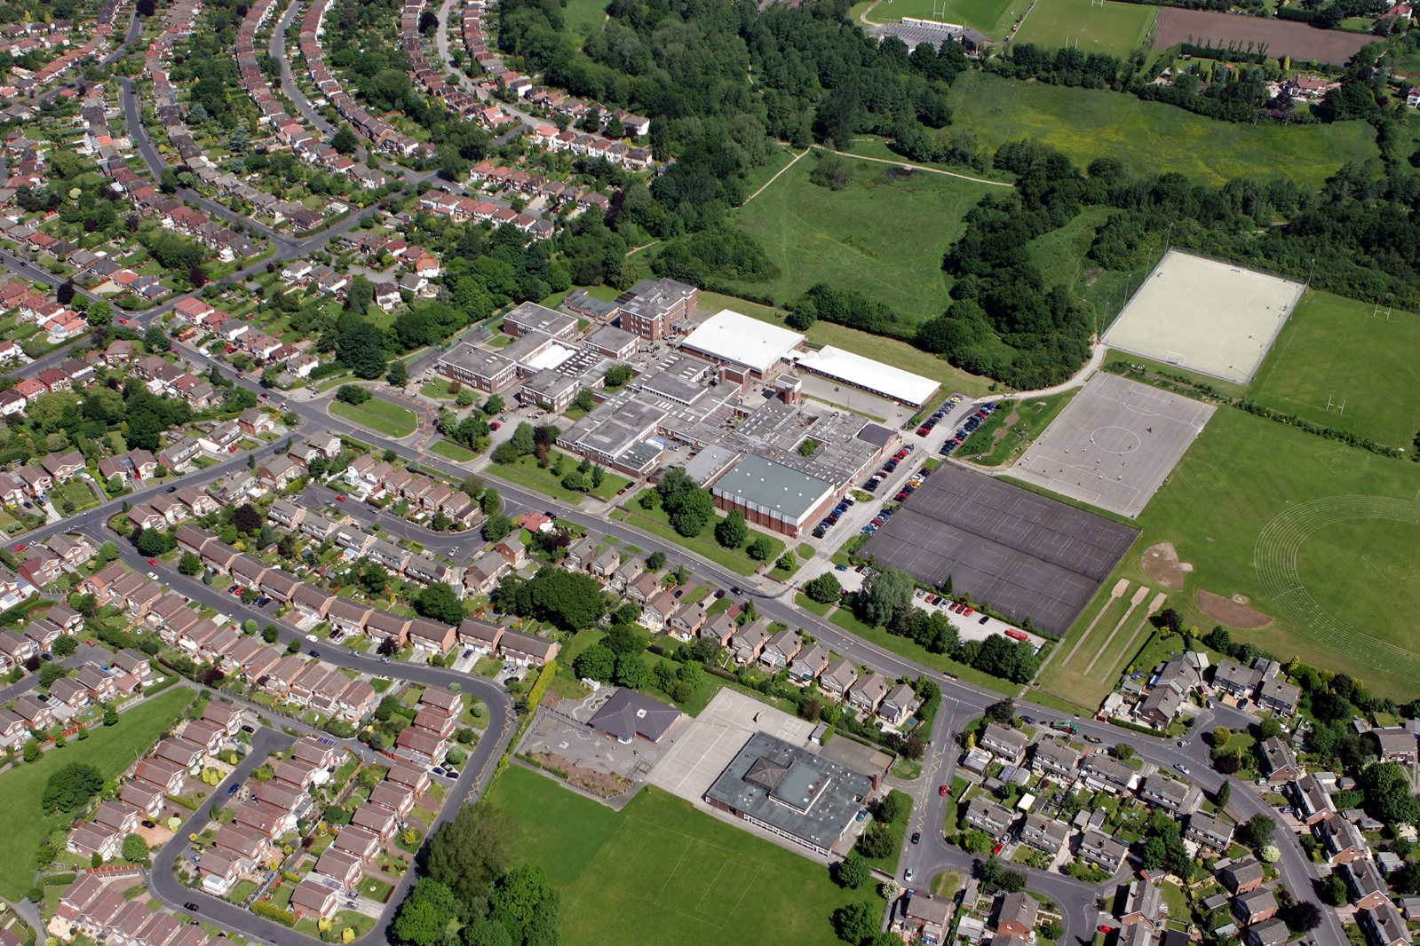



fgf
DOCUMENT TITLE
SUBTITLE

AUTHOR:
REVIEW DATE:
DEPARTMENT

Departments to complete the ‘careers activities in departments’ column. Please note we do not expect departments to cover all benchmarks.

Benchmark | Examples of activities | Careers activities in departments
Benchmark 2 Learning from career and labour market information  All pupils, parents and carers, teachers and staff who support pupils have access to good-quality, up-to-date information about future pathways, study options and labour market opportunities. | - Information about future pathways  - Information about the labour market for parents.  - Information about the labour market for pupils/carers.  - STEM | Description of Activities:  Year 9 Options talks – subject teachers explain where each subject can take them and what skills are needed for each subject. For example, law, journalism and education  Year 9 Options evening – Post 16 pathways and opportunities explained, offering experiences of prior students pathways  GCSE skills – Students develop key skills of source analysis, interpretation and evaluation
Benchmark 3: Addressing the needs of each young person  Students have different career guidance needs at different stages. Opportunities for advice and support need to be tailored to the needs of each student. | - Aspiration raising  - Addressing stereotypes  - SEND and vulnerable students  - Local authority collaboration  - Other | Description of Activities:  Beamish Visit – Students take part in residential visit to Beamish Open Air Museum in County Durham to learn about the industrial revolution. The 350 site includes a wide range of historic environments and experiences.  Regular marking of work – Students have continuous feedback and praise to support raising their aspirations  History lunch club – Students have opportunity to discuss their learning and the learning of other histories with one another in history club every week
Benchmark 4: Linking curriculum learning to careers  All teachers should link curriculum learning with careers. Subject teachers should highlight the progression routes for their subject and the relevance of the knowledge and skills developed in their subject for a wide range of career pathways. | - Careers embedded in the curriculum  - Employer involvement  - Employer mentoring  - Events & talks  - Business games & competitions  - Alumni activities  - Ready for work activities  - Employer encounters with parents  - Youth social action (campaigning, fundraising, volunteering)  - Other | Description of Activities:  First World War Battlefields – Link students learning to the battlefields where First World War soldiers fought. Students take part in a number of activities
Benchmark 5:  Employer encounters  Every student should have multiple opportunities to learn from employers about work, employment and the skills that are valued in the workplace. This can be through a range of enrichment activities including visiting speakers, mentoring and enterprise schemes | - Employer involvement in the curriculum  - Employer mentoring  - Events talks involving employers  - Business games and competitions  - Alumni activities  - Ready for work activities with employers  - Continuing professional development  - Workplace experience with parents  - Youth action (campaigning, fundraising, volunteering)  - other | Description of Activities:  Alumni Visits – Students who have continued history at A-level and degree level invited to speak with current students about their experiences.
Benchmark 6:  Workplace experience  Every student should have first-hand experiences of the workplace through work visits, work shadowing and/or work experience to help their exploration of career opportunities, and expand their networks. | - Volunteering  - Work experience  - Job shadowing  - Workplace visits  - Continuing professional development  - Workplace experience with parents  - Youth social action (campaigning, fundraising, volunteering)  - Other | Description of Activities:  Work Experience - Work experience visits to law firms, accountancy firms and libraries. Students also shadow the history department.  London trip visit – Student leaders taking part in trip to Parliament to better understand the workings of British democracy and the role of MPs.
Benchmark 7:  Encounters with further and higher education.  All students should understand the full range of learning opportunities that are available to them. This includes both academic and vocational routes and learning in schools, colleges, universities and in the workplace. | - Further education events and visits  - Application support for further education  - Higher education events and visits  - Apprenticeship events and visits  - Application support for apprenticeships  - Educational encounters with parents  - Other | Description of Activities:
Benchmark 8  Personal guidance | - One to one careers guidance  - Group careers guidance  - Other | Description of Activities:

