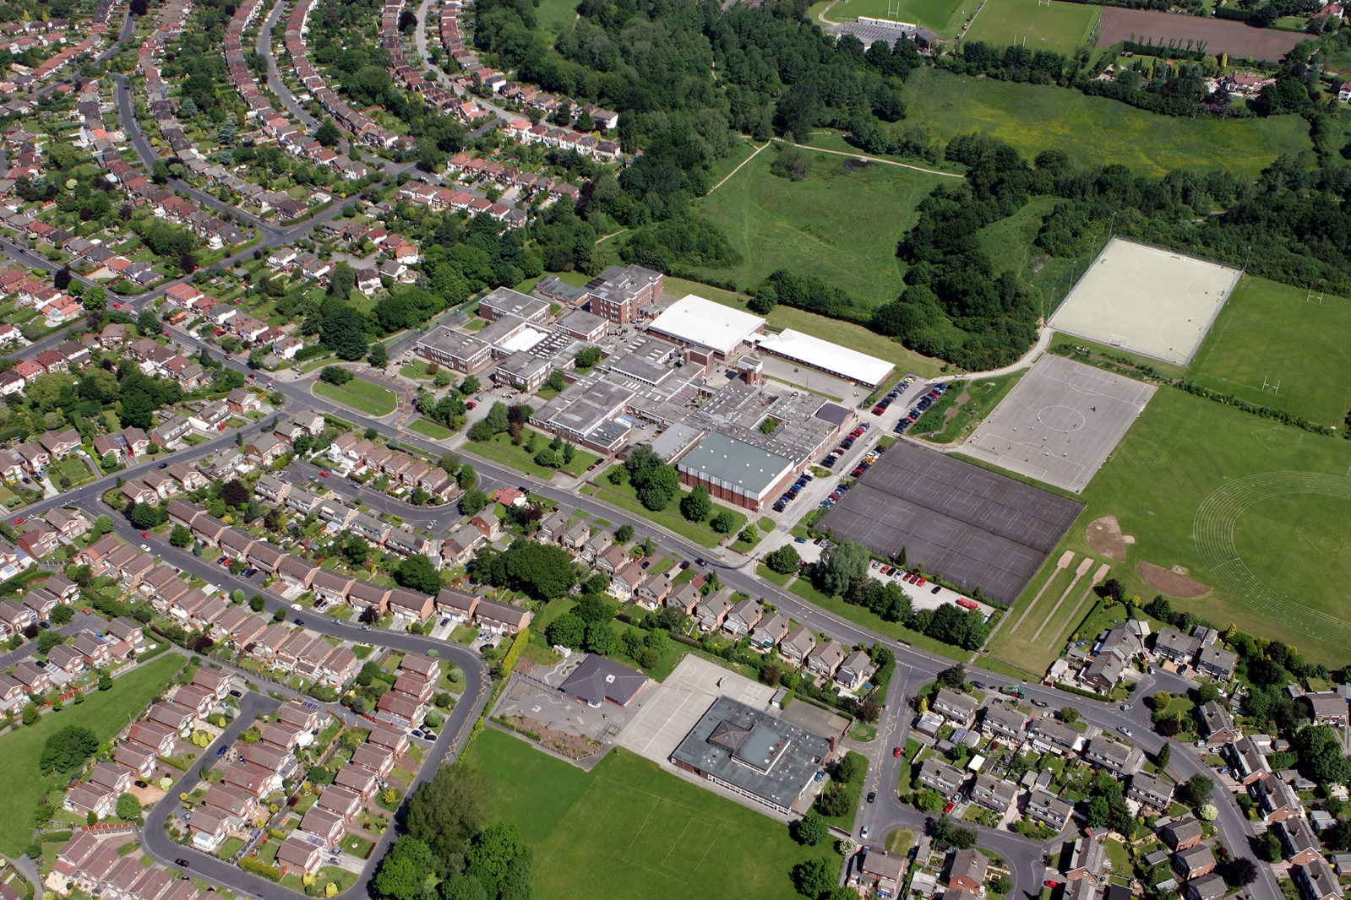


PROVIDER ACCESS POLICY
CAREERS BEYOND BRAMHALL HIGH

AUTHOR: MRS K THORPE September 2025
REVIEW DATE: September 2026

Introduction:
This policy statement sets out the school’s arrangements for managing the access of providers to the school for the purpose of giving them information about the provider’s education or training offer. This complies with the school’s legal obligations under Section 42B of the Education Act 1997.

The updated provider access legislation (PAL) has now been enacted. It specifies schools with KS3 and KS4 must provide at least four encounters with approved providers of apprenticeships and technical education for all their students. This new legislation will become a key mechanism to further help learners understand and take-up, not just apprenticeships, but wider technical education options such as T-Levels and Higher Technical Qualifications.

Commitment:
Bramhall High School is committed to ensuring students have an opportunity to access a range of education and training providers to inform them about approved technical education qualifications and apprenticeships. Bramhall High School is aware of its responsibility to set students on the path that will secure the best outcome enabling them to progress in education and work and give employers the highly skilled people they need. That means acting impartially, in line with the statutory duty, and not showing bias towards any route, be that academic or technical.

Bramhall High School endeavours to ensure that all students are aware of all routes to higher skills and are able to access information on technical options and apprenticeships (The Department of Education, July 2021: “Baker Clause”: supporting students to understand the full range of education and training options, and the Provider Access Legislation, January 2023).

Aims:
Bramhall High School’s Provider Access Policy has the following aims:

To develop our student’s knowledge and awareness of all career pathways available to them, including technical qualifications and apprenticeships.

To support young people to learn more about opportunities for education and training outside of school before making crucial choices about their future options.

To reduce drop out from courses and avoid the risk of students becoming NEET (Young people not in education, employment or training).

Student entitlement:
Bramhall High School fully supports the statutory requirement for students to have direct access to other providers of further education training, technical training and apprenticeships. The school will comply with the new legal requirement to deliver at least four encounters with providers of approved technical education qualifications or apprenticeships. This will be done in assemblies in National Apprenticeship Week and National University week, in addition to providers attending careers events at school.

At Bramhall High School all pupils in years 7 to 11 will:

• find out about technical education qualifications and apprenticeships opportunities, as part of a careers programme which provides information on the full range of education and training options available at each transition point;

• hear from a range of local providers about the opportunities they offer, including technical education and apprenticeships – through options events, assemblies, employer encounters and taster events;

• understand how to make applications for the full range of academic and technical courses.

For pupils of compulsory school age these encounters are mandatory. There will be a minimum of two encounters for pupils during the ‘first key phase’ (year 8 to 9) and two encounters for pupils during the ‘second key phase’ (year 10 to 11).

These provider encounters will be scheduled during the main school hours, and the provider will be given a reasonable amount of time to, as a minimum:

• share information about both the provider and the approved technical education qualification and apprenticeships they offer

• explain what career routes those options could lead to

• provide insights into what it might be like to learn or train with that provider (including the opportunity to meet staff and pupils from the provider)

• answer questions from pupils

Meaningful provider encounters:
One encounter is defined as one meeting/session between pupils and one provider. This can also be a meaningful online engagement where providers are able to offer live online engagement with our pupils.

Previous provider encounters at Bramhall High School:
2025 Post 16 providers who have delivered assemblies to our students:
- Aquinas
- The Laurus Trust Cheadle Hulme
- Xaverian College
- The Cheadle and Marple College
- Stockport college
- Poynton Sixth form
- The Laurus Trust Hazel Grove
- Macclesfield College
- Access Creative College
- The Army
- Elevated Knowledge
- Greater Manchester police
- Amazing apprenticeships – ASK scheme
Management of provider access requests:
Procedure – A provider wishing to request access should contact:
Senior Deputy Headteacher – Ms N Joynson: njoynson@bramhallhigh.stockport.sch.uk
Head of Careers: Mrs K Thorpe: kthorpe@bramhallhigh.stockport.sch.uk

Opportunities for access:
The school offers the four provider encounters required by law and additional events, integrated into the school careers programme. We will offer providers an opportunity to come into school to speak to pupils or their parents or carers.

Bramhall High Careers programme to cover the pupil entitlement of meaningful encounters:

Year 7 | - National apprenticeship week assembly delivered by an external training provider and alumni speaker.  - National university week assembly delivered by an alumni speaker.
Year 8 | - National apprenticeship week assembly delivered by an external training provider and alumni speaker.  - National university week assembly delivered by an alumni speaker.
Year 9 | - Assembly National apprenticeship week assembly delivered by an external training provider and alumni speaker.  - National university week assembly delivered by an alumni speaker.  - Post 16 careers fair (evening session not counted in PAL)  - Year 9 Careers morning encounter with an employer linked to their interests. 2 encounters per student.
Year 10 | - Work experience – 5 days.  - College taster days; Stockport College and Aquinas College.  - Post 16 Careers fair (evening session not counted in PAL)
Year 11 | - 1:1 careers advisor meeting from the Young People's Education and Careers Advice Service.  - Multiple Assemblies from post 16 providers – at least 8 in the Autumn term.

Please note we deliver a post 16 careers fair, student have encounters with over 30 different colleges, sixth forms and employers. However, as it is not delivered in school hours it cannot be classed as a meaningful encounter that meets the legal requirement.

Destination of our pupils:
Last year our pupils moved onto a range of providers in the local area

- Aquinas
- The Laurus Trust Cheadle Hulme
- Xaverian College
- The Cheadle and Marple College
- Stockport college
- Poynton Sixth form
- The Laurus Trust Hazel Grove
- Macclesfield College
- Manchester College
- Loretto
- Tameside College
Parents and Carers:
Parental involvement is encouraged, and parents may be invited to attend the events to meet the providers.
Management:
The Careers Leader coordinates all provider requests and is responsible to her senior management line manager.

Premisses and facilities:
The school will make the main hall, classrooms or private meeting rooms available for discussions between the provider and pupils, as appropriate to the activity. The school will also make available AV and other specialist equipment to support provider presentations. This will all be discussed and agreed in advance of the visit with the Careers Leader or a member of their team. Meaningful online engagement is also an option and we are open to providers that can provide live online engagement with our pupils. Providers are welcome to leave a copy of their prospectus or other relevant course literature in the school library, (access managed by the school librarian). The library is available to all pupils at lunch and break times.

Appropriate safeguarding checks will be carried out. Providers will be met and supervised by a member of the Careers Team.

Guest speakers: Please see our ‘Inviting guest speakers into Bramall High’ guide to help you prepare for your visit.

Complaints:
Any complaints with regards to provider access can be raised through the school complaints procedure or directly with The Careers & Enterprise Company via provideraccess@careersandenterprise.co.uk

Links with other policies
This policy supports and is underpinned by key school policies, including those for Careers, Child Protection, Equality and Diversity, and SEND.

Requests for access
Requests for access should be directed to Mrs K Thorpe, Careers Leader.

Grounds for granting requests for access
Access will be given for providers to attend school assemblies, timetabled Careers events arranged by Bramhall High School. Students may also travel to visit another provider as part of the trip organised in partnership with Bramhall High School.

Development:
This policy has been developed and is reviewed annually by the Careers Leader, Mrs K Thorpe and Senior Deputy Headteacher Mrs N Joynson. It is based on current good practice guidelines by the Department for Education.

Approval and review:
September 2025 Policy reviewed by Mrs K Thorpe, Careers Leader. kthorpe@bramhallhigh.stockport.sch.uk

Next review September 2026

Policy Overseen by Ms N Joynson, Senior Deputy Head teacher njoynson@bramhallhigh.stockport.sch.uk

Approved 31.01.2024 by Governors at Curriculum and Standards Committee
Signed: Chair of Governors

Headteacher, Mr P Williams headteacher@bramhallhigh.stockport.sch.uk

