
Bramhall High School Alumni
Calling all former students…

If you’re a former student of Bramhall High, we want to hear from you!

Your experiences since leaving could help to motivate and inspire our current students to feel more confident in making decisions about their future. We would love you to join our alumni network and stay connected with the school.

It doesn’t matter when you left us, whether you’re in further education or employment, whether you still live nearby or have moved further away, there are still ways you can help.

In order to sign up:

 submit your details here https://forms.office.com/e/tr56BJMw2b

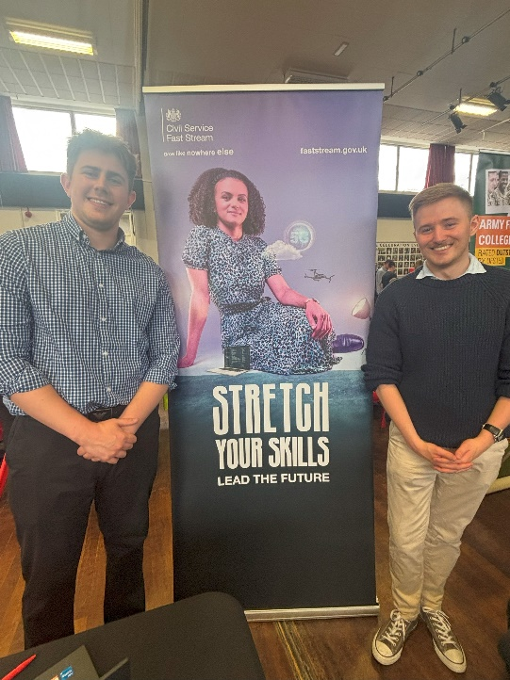
Join our alumni: Linkedin- Bramhall High School www.linkedin.com/groups/8190453/

Or for any questions email kthorpe@bramhallhigh.stockport.sch.uk

Ways you can get involved:
- Employer mentoring
- Delivery of assemblies and talks
- Attend our careers fair
- Workshops
- Job shadowing
- Fundraising
- Addressing stereotypes
- Employer involvement in our curriculum
- Small group focus sessions/mentoring
- Projects and challenges in related subjects
- Work place visits (site tours)
- Talks from your colleagues about the world of work and career pathways
- Team building exercises and work related challenges
- Work experience placement opportunities

