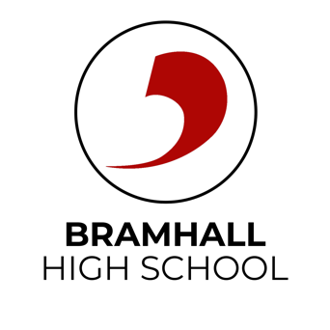
Preparing for interviews
Your interview

This document was written by our Careers and Enterprise Advisor Vicky Mullis from DJS Research.

Interviews can be something that can cause panic for people of all ages, let alone for a young person making their way in the world. Therefore the mind-set you have before an interview is crucial. The people interviewing you want to know about your personal qualities, experiences and characteristics. When they know this information they will decide if you are suitable for a position in a college, university, apprenticeship or job. Therefore interviews should be viewed as an opportunity to impress rather than something to be feared.
An interview is also a chance for you to get to know more about the job, course, business or college – think of it as an opportunity for you to ‘interview’ them.

Some useful tips

- Dress smartly and appropriately
- Arrive at least 15 minutes early
- Try to prepare some answers before hand
- Be polite and courteous
- Maintain eye contact
- Always seem keen and enthusiastic
- Research the company or post-16 provider
- Think of some questions to find out more about the course or job
- Take with you, your CV or portfolio and reference.

