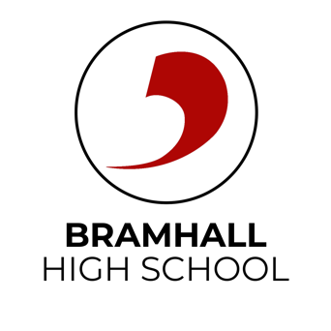
Writing a CV
Your Curriculum Vitae (CV)

This document was written by our Careers and Enterprise Advisor Vicky Mullis from DJS Research.

A CV is a crucial tool in your professional or academic toolkit. A well written CV is often the first point of contact between you and a potential employer, it’s an introduction to who you are and help shapes the employer’s first impression of you. In many ways your CV is your professional brand, allowing you to showcase your skills and experience in a short document. Writing a CV from scratch is daunting but the process is a great opportunity for you to identify your strengths and really think about how you can sell yourself. Properly investing time in writing your CV will be time well spent. Most job applications usually require a CV so having one that you just need to tailor means you can apply for opportunities quickly.

Top tips for writing a CV that will create a strong impression:

- Include a strong personal statement and/or consider a covering letter
- Start with a short personal statement that briefly highlights your key skills and experiences that are specific and tailored to the role. This your chance to stand out from the crowd, why should they pick you?

- Tailor your CV
- Customise the content for each application. Showcase the skills and experience that are most relevant and match these to what they are looking for

- Keep it concise and clear
- Limit your CV to 1 or 2 pages - avoid long paragraphs and keep to the point
- Use a clean professional layout (there are lots of layouts online), use headings, white space and bullet points to make it easy to read and nice to look at

- Achievements, education, skills
- Highlight your achievements and provide clear examples. Using strong action verbs like ‘led’, ‘managed’, ‘delivered’ as that sounds more impactful
- List, education and training certificates, including dates and institutions. Don’t forget to include training that might not be related to your academic studies but demonstrates your interests, other skills and achievements e.g., a clean driving license
- Include a key skills section to highlight your most relevant skills – hard skills (technical) and soft skills (interpersonal). Think about the skills you have that might be transferable

- Keep it updated
- Make sure it reflects your most recent and current experience, skills and achievements. Once you’ve written your CV it’s quick and easy to tailor it and keep it up to date

Finally, before you send it …
- Proof read it thoroughly, make sure it reads well, is free of typos, spelling mistakes or grammatical errors
- Review it for formatting and layout so that it looks consistent and clear
- Ask for feedback from other people and if possible from people that know you in different capacities (friend, family, teacher, employer)
- Include your contact information and make sure that it’s up to date and looks professional (name, address, phone number, email)

